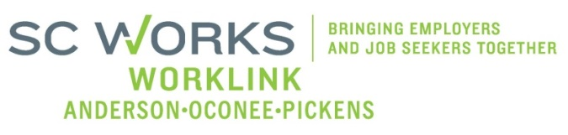

WORKFORCE INVESTMENT BOARD
YOUTH COUNCIL MEETING
AGENDA
Monday, October 7, 2013
11:00 A.M. - 12:00 P.M.

Board Room - Madren Center - Clemson University

- Welcome and Introductions Kristi King-Brock

- Approval of Minutes (8/4/13) Kristi King-Brock

- Palmetto Youth Connections (Report) Dana Grant/Karen Craven

- Old Business:
2013 AOPBIS Event Update Brandi Runion/Rick Murphy
PY13 YC Outreach Committee Update/Status Kristi King-Brock
WIA Youth Suitability Checklist Update/Status PYC/King-Brock
Youth-Board Presentation #2 - Final K. Craven/ Sharon G-Crite
PY 13 Youth Performance Goals- 3rd Qtr. Kristi King-Brock
PY 13 Youth Program Financial Update (7/01/13-8/25/13) Brandi Runion

- New Business:
Guest Speaker: Business Development Specialist Anna Connelly, AOP-SCVRD
Topic: Call in the SWAT Team
Youth Council Membership Application (1) Kristi King-Brock

- Other Business: Kristi King-Brock Reminder: Youth Council Re-Treat (January 13, 2014) Kristi King-Brock
Adjourn Kristi King-Brock

Next Youth Council Meeting, January 13, 2014 - 11:00am-12:45pm
Madren Center, Clemson University

