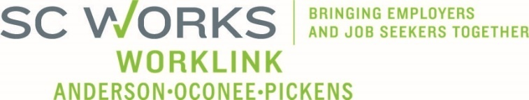

**WORKFORCE DEVELOPMENT BOARD**

**One Stop Operations Committee**

**January 15, 2025 at 3:00pm**

**SC Works Clemson Comprehensive Center, Large Conference Room**

Conference Call Information:

<https://us02web.zoom.us/j/6436419262?pwd=Vm9zNTB2ZDNYU3ZWZno1ZlM2QVBqdz09>

Meeting ID: 643 641 9262 Dial: 1-646-558-8656 Passcode: 29631

**AGENDA**

1. **Call to Order/Introductions** David Bowers, Chair
2. **Consent Agenda\*** David Bowers
   1. Meeting Minutes (10.16.2024)
   2. PY2024 Usage Reports
   3. PY2024 Financial Reports
   4. PY2024 Employer Service Reports
3. **SC Works System Updates** 
   1. Employer Services Update Andie Keef, SC DEW Staff
   2. PY2024 SC Works Center Update Billy Hunter, Eckerd WDS
   3. OJT Update
   4. Rapid Response - Incumbent Worker Training Update Jennifer Campbell, WorkLink Staff
   5. Tentative Strategic Plan Summary- Information only
   6. Business Services Representative*
   7. March Meeting Date*

1. **WIOA Program Updates** 
   1. PY2024 Program Update Jeff Snider, Eckerd
   2. Proposed Policy Mod – Self-Sufficiency Wage* Windy Graham, WorkLink Staff

1. **Other Business** David Bowers
   1. PY2025 Eckerd Grant Extensions/RFPs* Jennifer Kelly, Executive Director
2. **Adjourn**

*\*Denotes voting item*

|  |
| --- |
| **UPCOMING MEETINGS:**  **WorkLink WDB Meeting**, February 5, 2025 @ 1pm  *Madren Center (Lunch at Noon)*  **OneStop Operations Committee Meeting**, March TBD  Clemson SC Works, Large Conference Room or Conference Call |