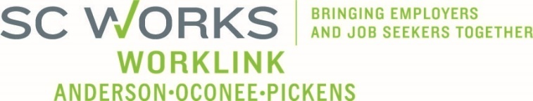

WORKFORCE DEVELOPMENT BOARD
Finance Committee
May 28, 2025 at 3:00pm
Zoom Call Information:
https://us02web.zoom.us/j/6436419262?pwd=Vm9zNTB2ZDNYU3ZWZno1ZlM2QVBqdz09
Meeting ID: 643 641 9262 Dial: 1-646-558-8656 Passcode: 29631

AGENDA

- Call to Order/Introductions Mike Wallace

- Approval of Meeting Minutes (10.30.2024)* Mike Wallace

- PY2023 In-House Budget Review Jennifer Campbell, Interim Director
  - In-House Budget
  - Expenditure Status (as of 4.30.2025)

- Incumbent Worker Training Grants

- Eckerd Workforce Development Services
  - Adult/DW Operator (All Sources) Billy Hunter, Eckerd Staff
  - Adult/DW Program (All Sources) Jeff Snider, Eckerd Staff
  - Youth Program (All Sources) Karen Craven, Eckerd Staff

- PY2025 Provisional Budget Review Jennifer Campbell
  - Allocations
  - In-house budget*
  - Adult/DW Program* Renee Alexander, Eckerd Sr. Operations Director
  - Adult/DW Operator*
  - Youth Program*

- Other Business Mike Wallace

- Adjourn

UPCOMING MEETINGS:

WorkLink WDB Meeting, June 4, 2025 @ 1pm
Madren Center (Lunch at Noon)

Finance Committee Meeting, August 27, 2025 @ 3pm
Clemson SC Works, Large Conference Room or Conference Call

