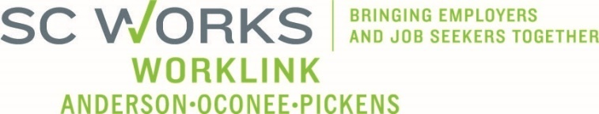

WORKFORCE DEVELOPMENT BOARD
Finance Committee
August 27, 2025 at 3:00pm
SC Works Clemson Comprehensive Center, Large Conference Room
Conference Call Information:
https://us02web.zoom.us/j/6436419262?pwd=Vm9zNTB2ZDNYU3ZWZno1ZlM2QVBqdz09
Meeting ID: 643 641 9262 Dial: 1-646-558-8656 Passcode: 29631

AGENDA

- Call to Order/Introductions Stephanie Collins, Chair

- Approval of Meeting Minutes (5.28.2025)* Stephanie Collins

- PY2024 Final In-House Budget Review Jennifer Campbell, WorkLink Staff

- PY2025 In-House Budget Review*

- Rapid Response / Incumbent Worker Training Grants

- PY2024 Final & PY2025 Eckerd Workforce Development Services
  - Adult/DW Operator (All Sources) Billy Hunter, Eckerd Staff
  - Adult/DW Program (All Sources) Jeff Snider, Eckerd Staff
  - Youth Program (All Sources) Ann Marie Baker, PYC Staff

- Other Business Stephanie Collins

- Adjourn

UPCOMING MEETINGS:

WorkLink WDB Meeting, September 10, 2025 @ 1pm
Clemson Visitor’s Center (Lunch at Noon)

Finance Committee Meeting, October 22, 2025 @ 3pm
Conference Call

