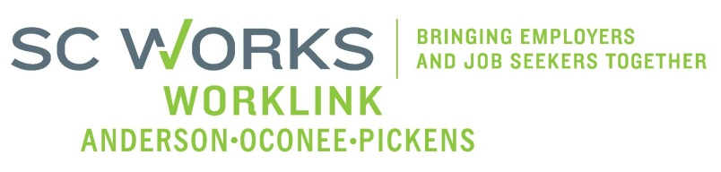

WORKFORCE DEVELOPMENT BOARD
YOUTH COMMITTEE MEETING
AGENDA
Tuesday, August 12, 2025
10:00 A.M. – 11:00 A. M.

Location: Zoom- Virtual Meeting

- Welcome - Introductions Katie Brown, Chair

- Review of Minutes (3/04/2025)* Katie Brown Chair

- PY 24 PYC Report/Dashboard (6/30/2025) Ann Marie Baker, PYC Prog. Mgr.

- New Business:
PY 24 (Final) New Enrollment Report Katie Brown
PY 24 Youth Local Monitoring Report- Information Only Katie Brown
PY 24 Grant Expenditures (Final)- (6/30/2025) Ann Marie Baker
PY 24 3rd & 4th Qrt WL Youth Performance Jennifer Campbell, WorkLink
PY 25 Electronic File Update- Information Only Jennifer Campbell
PY 25 Letter of Intent Jennifer Campbell
PY 24 Anderson Impact Awards Nomination* Ann Marie Baker

- Other Business: Katie Brown

- Adjourn* Katie Brown

*Vote Needed

Next Scheduled Board Meeting – September 10, 2025
In person- Clemson Visitor’s Center

Next Scheduled Youth Committee Meeting – October 7, 2025
Zoom Virtual Meeting

