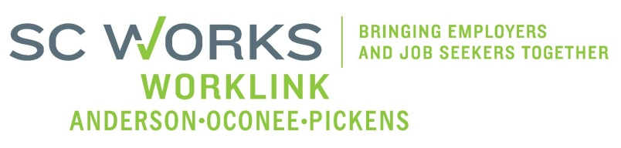

WORKFORCE DEVELOPMENT BOARD
YOUTH COMMITTEE MEETING
AGENDA
Tuesday, October 7, 2025
10:00 A.M. – 11:00 A. M.

Location: Zoom- Virtual Meeting

- Welcome - Introductions Katie Brown, Chair

- Review of Minutes (8/12/2025)* Katie Brown Chair

- Review of updated Minute format* Jennifer Campbell, WorkLink

- PY 25 PYC Report/Dashboard (7/1/2025 - 8/31/2025) Ann Marie Baker, PYC Prog. Mgr.

- New Business:
PY 25 Revised Youth Formula Grant (Mod #1) Renee Alexander, Eckerd Connects

- Other Business: Katie Brown
2026 Youth Committee Dates*

- Adjourn* Katie Brown

*Vote Needed

Next Scheduled Board Meeting – November 5, 2025
In person- Clemson Visitor’s Center

Next Scheduled Youth Committee Meeting – Pending Approval
Zoom Virtual Meeting

