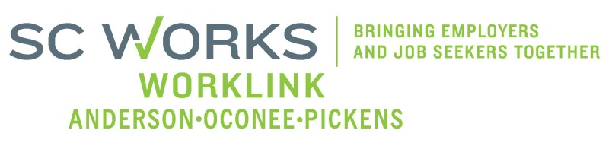

**WORKFORCE DEVELOPMENT BOARD**

**YOUTH COMMITTEE MEETING**

**AGENDA**

**Tuesday, January 21, 2025**

**“Zoom Meeting”**

**10:00 A.M. – 11:00 A. M.**

**Location: SC Works Center Clemson**

1. Welcome - Introductions Katie Brown, New YC Chair
2. **Review of Minutes** (5/07/2024)* Katie Brown, Chair

1. PY 23 PYC **Final** Report/Dashboard (June 30, 2024) Karen Craven, PYC Prog. Mgr.

PY 24 PYC Report/ Dashboard (10/01/-12-31-2024)

1. **New Business**:

PY 23 **Final** Grant Expenditure (June 30, 2024) Karen Craven

PY 24 New Grant Expenditure (12/31/2024 Karen Craven

PY 24 New Enrollment Report (12/31/2024) Katie Brown, Chair

PY 23 **Fina**l WL Youth Performance (7/1/2023-6/30/2024) Jennifer Campbell, Asst. Director

PY 24 1st Quarter WL Youth Performance Jennifer Campbell

PY 23 Final WEX Update Jennifer Campbell

PY 25 WorkLink Draft Strategic Plan Strategies Jennifer Kelly, Exec. Director

PY 23 SCDEW (State) Monitoring Report Jennifer Kelly

1. **Other Business**: Katie Brown, Chair

* **Please complete “Conflict of Interest Form” return to WorkLink no later than close of business Friday, January 24, 2025.**
* **Review PY 25 WL Strategic Plan Strategies (in YC committer packet). Send your input or edits to Jennifer Kelly, WorkLink Executive Director (** [**jkelly@worklinkweb.com**](mailto:jkelly@worklinkweb.com)**) no later than Friday, January 31, 2025.**

1. **Adjourn** Katie Brown, Chair

**\***Vote Needed

|  |
| --- |
| **Next Scheduled Youth Committee Meeting – March 4, 2025**  **“Zoom Meeting”** |