No money at the end of the month?

Creditors calling you all day?

Come to our FREE Financial Workshop and get some FREE information that could help you!!

Financial Workshop

February 21, 2025

10:00am-11:00am

SC Works Clemson

1376 Tiger Blvd., Suite 102

Clemson, SC 29631

If you are interested in this workshop, please contact

Billy Hunter at (864) 722-9273

Seating is limited, so call and reserve your seat NOW!

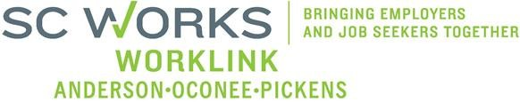There will be refreshments, also.

An equal Opportunity Employer/Program. Auxiliary aids and services available to individuals with disabilities.

TTY: Relay Service dial: 711

For program funding details and compliance with the Stevens Amendment, please visit www.dew.sc.gov