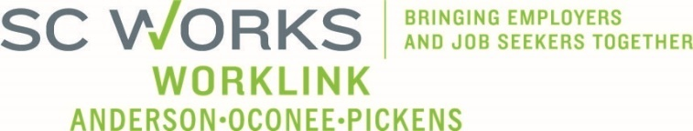

WORKFORCE DEVELOPMENT BOARD
One Stop Operations Committee
October 15, 2025, at 3:00pm
SC Works Clemson Comprehensive Center, Large Conference Room
Conference Call Information:
https://us02web.zoom.us/j/6436419262?pwd=Vm9zNTB2ZDNYU3ZWZno1ZlM2QVBqdz09
Meeting ID: 643 641 9262 Dial: 1-646-558-8656 Passcode: 29631

AGENDA

- Call to Order/Introductions Shonna Williams
- Review of AI- Generated Minute format* Jennifer Campbell, WorkLink
- Approval of 8.20.2025 Minutes*

- Consent Agenda* Shonna Williams
  - PY2025 Usage Reports
  - PY2025 Financial Reports

- SC Works System Updates
  - PY2025 Employer Services Update Andie Keef, SC DEW Staff
  - PY2025 SC Works Center Update Billy Hunter, Eckerd WDS
  - SC Works WorkLink Closure Policy
  - Rapid Response Jennifer Campbell, WorkLink Staff

- WIOA Program Updates
  - PY2025 Program Update Jeff Snider, Eckerd WDS
  - Success Story

- Other Business
  - PY2025 OSO Committee Meeting Dates*
    - Jan 14, March 18, May 20, Aug 19, Oct 21
  - New Committee Chair*
  - New Committee Vice Chair*

- Adjourn Shonna Williams

*Denotes voting item

UPCOMING MEETINGS:

WorkLink WDB Meeting, November 5 @ 1pm
Visitor Center (Lunch at Noon)

(if Approved) OneStop Operations Committee Meeting, January 14, 2026 @ 3pm
Clemson SC Works, Large Conference Room or Conference Call

