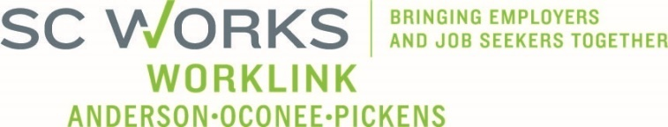

WORKFORCE DEVELOPMENT BOARD
OneStop Operations Committee Meeting Minutes
October 15, 2026 at 3:00pm
SC Works Clemson Comprehensive Center, Large Conference Room
With Conference Call Option

AGENDA
Members Present
David Bowers Danny Brothers Brad Blackston O’Neil Burton
Brooke Garren Brian Jones Hunter Kombe Jim Kilton
Ellen Pate Alex Vitou Shonna Williams

Members Absent:
Andie Keef Wendy Smith

Staff Present:
Jennifer Campbell Windy Graham

Guests Present:
Renee Alexander Billy Hunter Jeff Snider
Welcome and Introductions
Shonna Williams officially called the meeting to order at 3:02 p.m., welcoming all attendees and noting that the meeting would be recorded for the purpose of processing minutes.

Consent Agenda*
Chair Bowers stated that the consent agenda was included in the meeting packet. The consent agenda included the following items:
- 8.20.25 AI Generated Meeting Minutes
- PY25 Usage Reports
- PY25 Financial Reports
Review of AI-Generated Minute Format*
Jennifer Campbell presented the new AI-generated meeting minute format. The committee discussed benefits and limitations, including the absence of attendee names and motion makers in the automated output.

ACTION TAKEN: The committee voted to accept the AI-generated format for future minutes.
Approval of the August 20, 2025 minutes was tabled until missing details can be manually added.

ACTION TAKEN: Motion made by David Bowers and seconded by Jim Kilton to approve the consent agenda. The motion carried unanimously.
SC Works Employer Services Updates
  - • 12 hiring events held July–August, serving 521 job seekers.
  - Upcoming events include:
  - Anderson Library Job Fair – October 22
  - Veteran-focused event in November
  - AOP Showcase planned for 6,000 eighth-grade students.
Center Updates (Presented By Billy Hunter)
  - Workshop and information session attendance slightly increased over last year.
Key upcoming dates:
  - Clemson Office Closure – October 31
  - Veterans Day – November 11
  - Staff Training & Thanksgiving Meal – November 2
SC Works WorkLink Closure Policy*
Billy reviewed the updated closure policy, including procedures for power outages and communication protocols with the Executive Director and Board Chair.

ACTION TAKEN: Motion made by David Bowers and seconded by Jim Kilton to approve the WorkLink Closure Policy as presented. The motion carried unanimously.

Rapid Response
Jennifer Campbell provided updates and reminders regarding rapid response procedures.

WIOA Program Updates (Presented by Jeff Snider)
- 26 new participants enrolled July–September; 30 total to date.
- $44,936 in scholarship funds leveraged through TCTC and Goodwill partnerships.
Success Story
- Christian Stone (Pickens County) recognized for strong progress and participant referrals.
- Tim Broom (Oconee County), a veteran, successfully completed CDL training and secured employment with TMC as a flatbed truck driver, improving financial stability for his family.

Other Business
PY2026 OSO Committee Meeting Dates*

Proposed dates for 2026 (all at 3:00 p.m.):

January 14, March 18, May 20, August 19, October 14

ACTION TAKEN: Motion made by David Bowers and seconded by Brian Jones to approve the 2026 meeting schedule. Motion carried unanimously.

New Committee Chair*

Nomination: Alex Vitou
ACTION TAKEN: Approved unanimously.

New Committee Vice Chair*

Nomination: David Bowers
ACTION TAKEN: Approved unanimously.

Announcements
    - Workforce Development Board Meeting scheduled for Novermber 5th at the Clemson Visitor Center.
    - Next OSO Committee Meeting scheduled for January 14, at 3:00 p.m.
Adjourn
With no further business, the meeting was adjourned at 3.58 pm.
Respectfully submitted,
Jennifer Campbell

