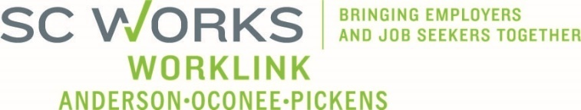

WORKFORCE DEVELOPMENT BOARD
One Stop Operations Committee
January 14, 2025 at 3:00pm
SC Works Clemson Comprehensive Center, Large Conference Room
Conference Call Information:
https://us02web.zoom.us/j/6436419262?pwd=Vm9zNTB2ZDNYU3ZWZno1ZlM2QVBqdz09
Meeting ID: 643 641 9262 Dial: 1-646-558-8656 Passcode: 29631

AGENDA

- Call to Order/Introductions Alex Vitou, Chair

- Consent Agenda* Alex Vitou
  - Amended Meeting Minutes (8.20.25)
  - Meeting Minutes (10.15.25)
  - PY2025 Usage Reports
  - PY2025 Financial Reports
  - PY2025 Employer Service Reports

- SC Works System Updates
  - Employer Services Update Andie Keef, SC DEW Staff
  - PY2025 SC Works Center Update Billy Hunter, Eckerd WDS
  - Rapid Response - Incumbent Worker Training Update Jennifer Campbell, WorkLink Staff
  - Business Services Representative

- WIOA Program Updates
  - PY2024 Program Update Stan Hill, Eckerd
  - Adult Budget Mod 1 – Update Jennifer Campbell
  - Proposed Policy Mod – Training Cap increase*

- Other Business
  - OSO Meeting Format* Alex Vitou
  - PY2026 Eckerd Grant Extensions/RFPs* Jennifer Campbell

- Adjourn

*Denotes voting item

UPCOMING MEETINGS:

WorkLink WDB Meeting, February 4, 2026 @ 1pm
Visitor Center (Lunch at Noon)

OneStop Operations Committee Meeting, March 18, 2026
Clemson SC Works, Large Conference Room or Conference Call

