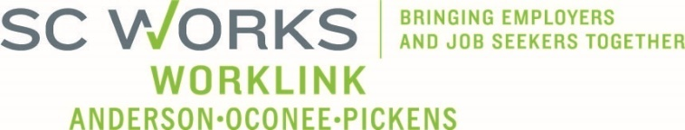

WORKFORCE DEVELOPMENT BOARD
One Stop Operations Committee
March 18, 2026 at 3:00pm
Microsoft Teams

AGENDA

- Call to Order/Introductions Alex Vitou, Chair

- Consent Agenda* Alex Vitou
  - Meeting Minutes (1.15.2024)
  - PY2025 Usage Reports
  - PY2025 Financial Reports
  - PY2025 Employer Service Reports

- SC Works System Updates
  - Employer Services Update Andie Keef, SC DEW Staff
  - PY2025 SC Works Center Update Billy Hunter, Eckerd WDS
  - Rapid Response - Incumbent Worker Training Update Jennifer Campbell,

- WIOA Program Updates
  - PY2025 Program Update Stan Hill, Eckerd WDS
  - EPTL Review* Windy Graham, WorkLink Staff

- Other Business Alex Vitou

- Adjourn

*Denotes voting item

UPCOMING MEETINGS:

WorkLink WDB Meeting, April 1, 2026 @ 1pm
Visitor Center (Lunch at Noon)

OneStop Operations Committee Meeting, May 20, 2026

