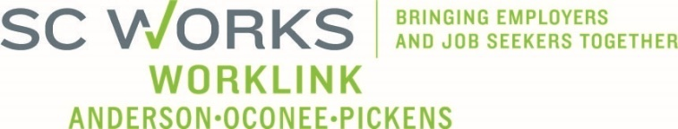

WORKFORCE DEVELOPMENT BOARD
Finance Committee
January 21, 2026 at 3:00pm
Conference Call Information:
https://us02web.zoom.us/j/6436419262?pwd=Vm9zNTB2ZDNYU3ZWZno1ZlM2QVBqdz09
Meeting ID: 643 641 9262 Dial: 1-646-558-8656 Passcode: 29631

AGENDA

- Call to Order/Introductions Mike Wallace

- Approval of Meeting Minutes (10.22.2025)* Mike Wallace

- PY2025 In-House Budget Review Jennifer Campbel, WorkLink Staff

- Rapid Response / Incumbent Worker Training Grants

- PY2025 Eckerd Workforce Development Services
  - Adult/DW Operator (All Sources) Billy Hunter, Eckerd Staff
  - Adult/DW Program (All Sources) Stan Hill, Eckerd Staff
  - Adult Program Mod 1 – Information Only Jennifer Campbell
  - Youth Program (All Sources) Ann Marie Baker, PYC Staff

- Other Business Mike Wallace
  - Program Services RFP *

- Adjourn

UPCOMING MEETINGS:

WorkLink WDB Meeting, February 4, 2026 @ 1pm
Clemson Visitor’s Center (Lunch at Noon)

Finance Committee Meeting, March 25, 2026 @ 3pm
Conference Call

