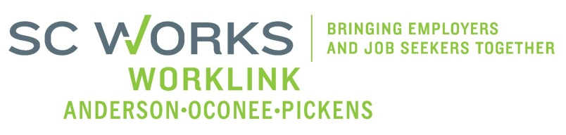

WORKFORCE DEVELOPMENT BOARD
Youth Committee
Tuesday, January 21, 2026 at 10:00 AM

Zoom Conference Call Information:
https://us02web.zoom.us/j/6436419262?pwd=Vm9zNTB2ZDNYU3ZWZno1ZlM2QVBqdz09
Meeting ID: 643 641 9262 Dial: 1-646-558-8656 Passcode: 29631

AGENDA

- Welcome - Introductions Katie Brown, Chair

- Review of Minutes (10.7.25)* Katie Brown, Chair

- PY 25 PYC Report/Dashboard Ann Marie Baker, PYC

- New Business:
PY2026 Eckerd Grant Extensions/RFPs* Jennifer Campbell, WorkLink

- Other Business: Katie Brown, Chair
March Meeting Date Change*

- Adjourn* Katie Brown, Chair

*Vote Needed

UPCOMING MEETINGS:

WorkLink WDB Meeting, February 4, 2026 @ 1pm
Visitor Center (Lunch at Noon)

Youth Committee Meeting, March TBD, 2026
Zoom Conference Call

