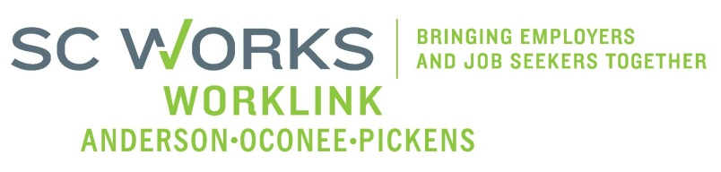

WORKFORCE DEVELOPMENT BOARD
Youth Committee
Tuesday, March 10, 2026 at 10:00 AM

Virtual Meeting- Teams Call

AGENDA

- Welcome - Introductions Katie Brown, Chair

- Review of Minutes (1.20.26)* Katie Brown, Chair

- PY 25 PYC Report/Dashboard Ann Marie Baker, PYC

- New Business:
PY 25 Grant Expenditure (1/31/26) Ann Marie Baker, PYC
Monitoring Update Jennifer Campbell, WorkLink
LEP & EO Training Scheduled for April 10, 2026

- Other Business: Katie Brown, Chair
PY2026 RFP Committee
Staffing Change

- Adjourn* Katie Brown, Chair

*Vote Needed

UPCOMING MEETINGS:

WorkLink WDB Meeting, April 1, 2026 @ 1pm
Visitor Center (Lunch at Noon)

Youth Committee Meeting, May 5, 2026
Teams Conference Call

