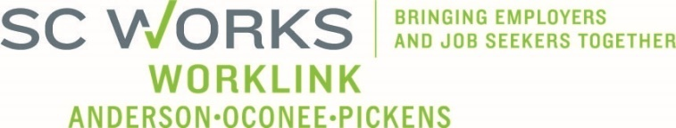

WORKFORCE DEVELOPMENT BOARD
One Stop Operations Committee
May 20, 2026, at 3:00pm
SC Works Clemson Comprehensive Center, Large Conference Room

AGENDA

This meeting has been cancelled.

UPCOMING MEETINGS:

WorkLink WDB Meeting, June 3 @ 1pm
Visitor Center (Lunch at Noon)

